# **COMP-1701 - Transferring Data to Databases**

## **Data Science & Machine Learning (DSML) - RRC Polytech**

Module B.2 - Database GUI - DBeaver EE: Signup, Academic License, Download, Install, Configurations

There are several Database Graphical User Interfaces (GUIs) that could be installed for MySQL servers. Some cost a few bucks, though for us, we always try to find freeware and in industry, the same goes. If we are seeking something that costs ourselves or businesses money, eventually you will gain the experience needed to justify the benefits of purchasing software in industry.

For this course, we will be using DBeaver EE (Enterprise Edition), and we are able to request an Academic License to the DBeaver group, so we get it for free (the right price for us).

DBeaver is a great GUI, that allows you to connect a whole plethora of database engines to it. The databases can be local, remote, in the cloud too.

For our course, we want you to learn how to develop locally and how to configure your laptop as if it were a server. All developers work locally, then deploy to test environments (for client testing), and once you receive the sign-off, then deployment to the production server would occur.

REMEMBER: BEFORE AND AFTER INSTALLATIONS OF ANY SOFTWARE, IT IS WISE TO FLUSH OUT YOUR CPU/RAM’s MEMORY BY PERFORMING A REBOOT.

Sign-Up Process

Visit <https://dbeaver.com/> and from the SIGN IN menu, choose Sign Up



Enter your basic information, using your **@academic.rrc.ca** email addresses (not ~~@rrc.ca~~), enter a **password** (twice, which you can cache in your browser), **first/last name**, and click the **I’m not a robot (reCAPTCHA)**.

Then click **CREATE ACCOUNT**.

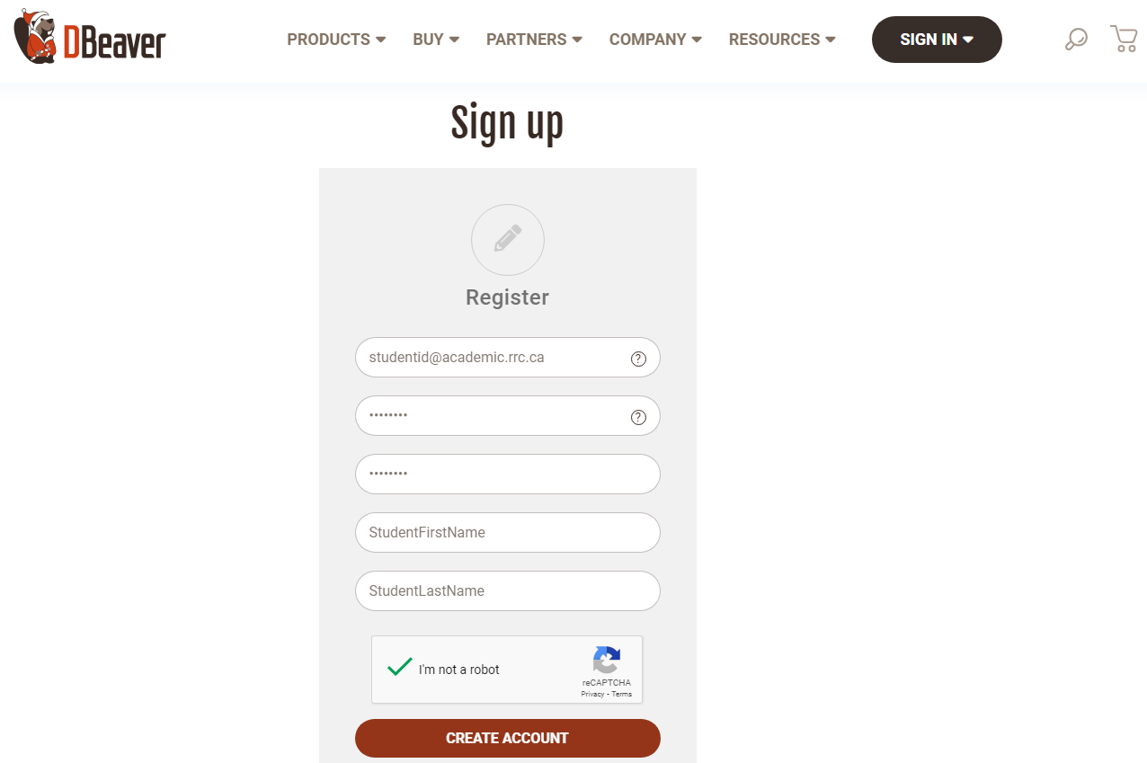

Note, upon completion, it indicates to check your email…

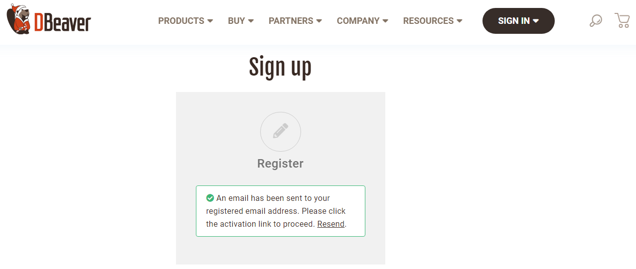

…then click on the Verify Account link, the email they sent you.

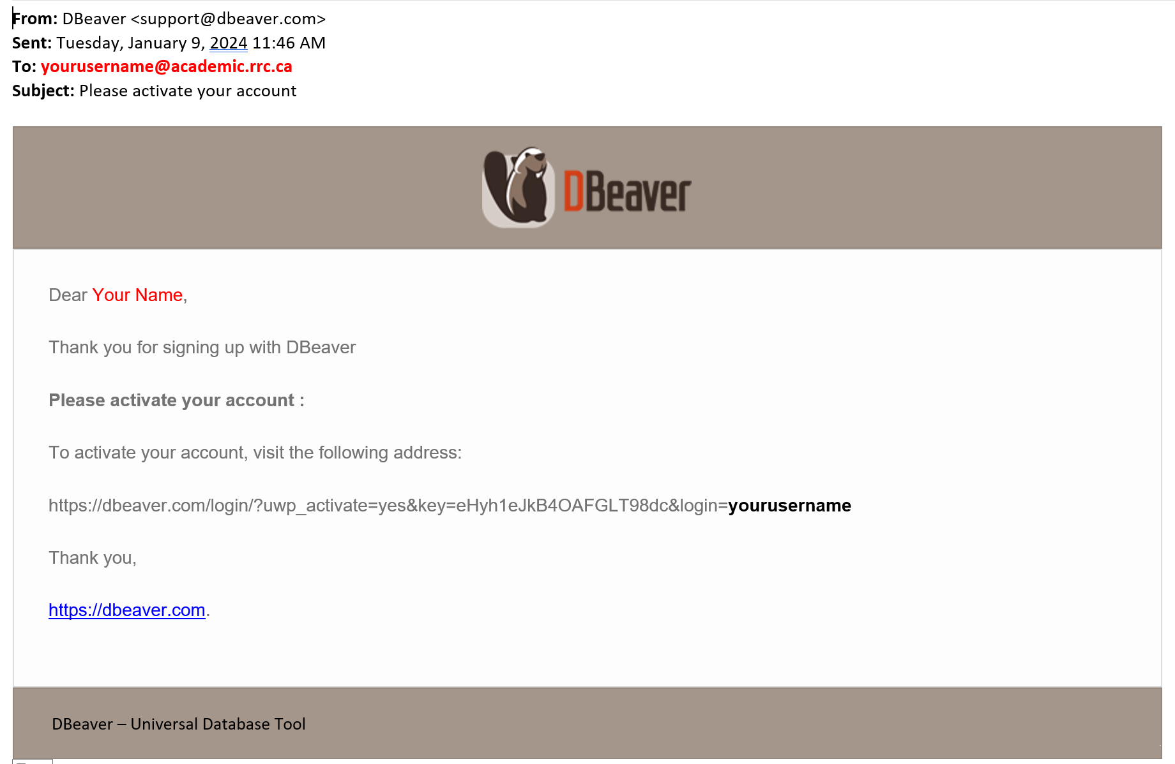

Upon clicking the link, it takes you to the **Sign In** (indicating your account was successfully activated). Enter your **@academic.rrc.ca** email account and **password**, then click **LOGIN** (it might be at this point that your browser will ask you to cache the account login details for this site, it could happen in the Sign Up as well, either or).

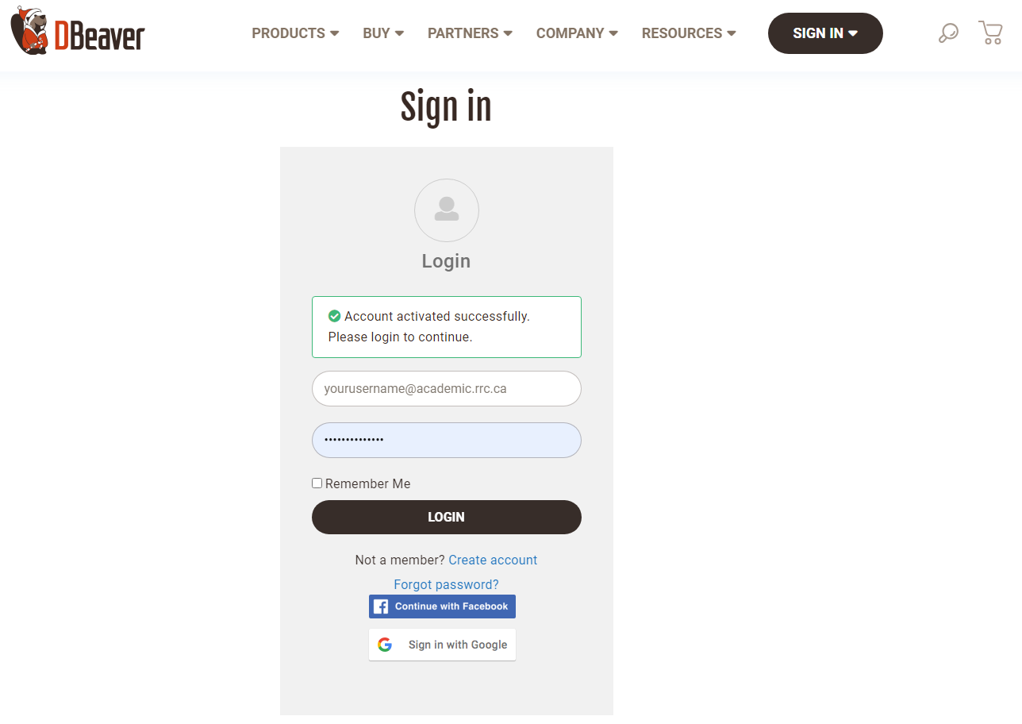

Enter your Profile information, you can enter:  
  
Company: **Red River College (RRC) Polytechnic**  
VAT: *(ignore this field)*Passwords: *(already done, ignore these fields)*  
Country: **Canada**  
ZIP: *(ignore this field)*  
City: **Winnipeg**  
State: **Manitoba**  
Address1: **161 Princess Ave**  
Address2: **R3B 1K9**

Then click **UPDATE ACCOUNT**.

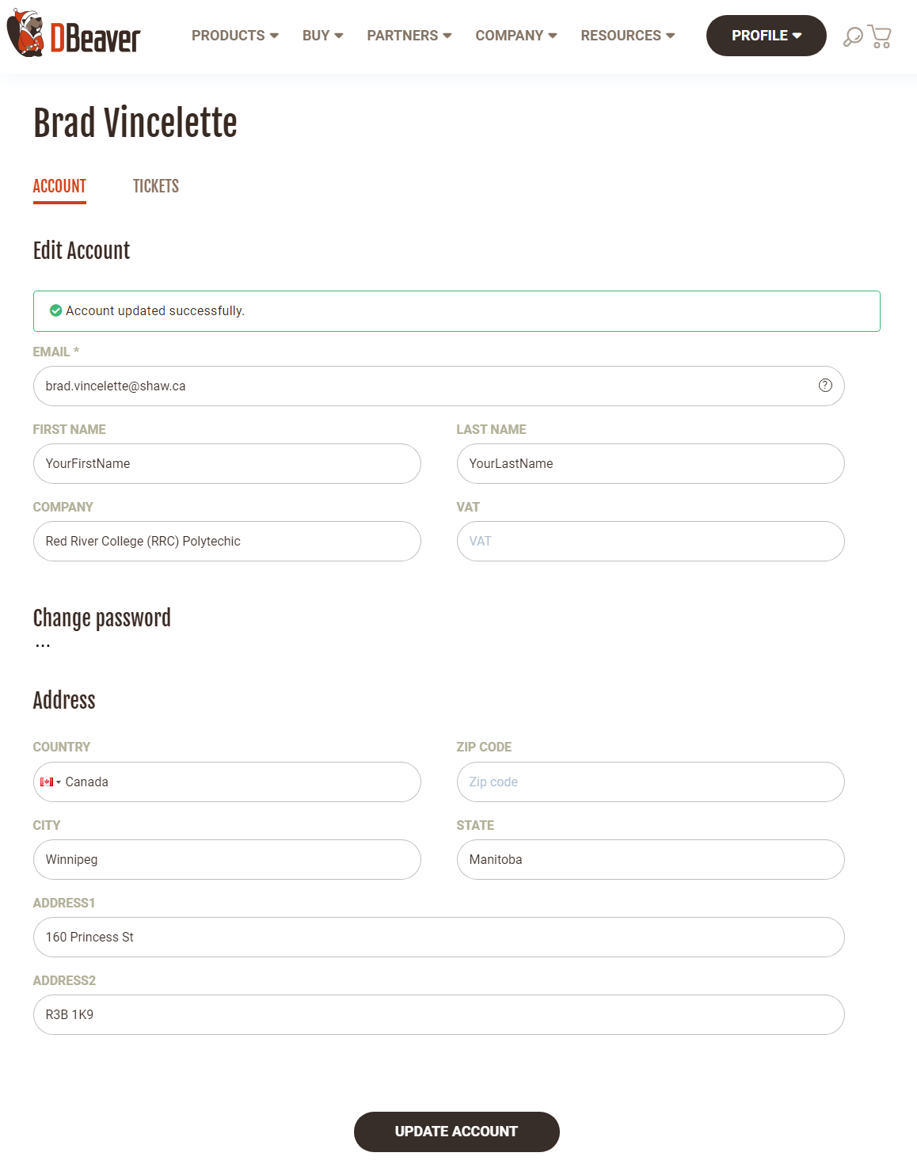

Academic License Request Process

Visit <https://dbeaver.com/academic-license/> and select DBeaver Enterprise under Product. If you are signed in, your information should be automatically filled in, if not, enter in the information required below, including the message requesting the DBeaver EE Academic License, you can copy and paste the following text:

I am a student at Red River College (RRC) Polytechnic in Winnipeg, Manitoba, Canada. I am requesting a DBeaver EE Academic License, as indicated by our Instructor, as we require it for our course COMP-1701 - Transforming Data Into Databases. Thank you!!!

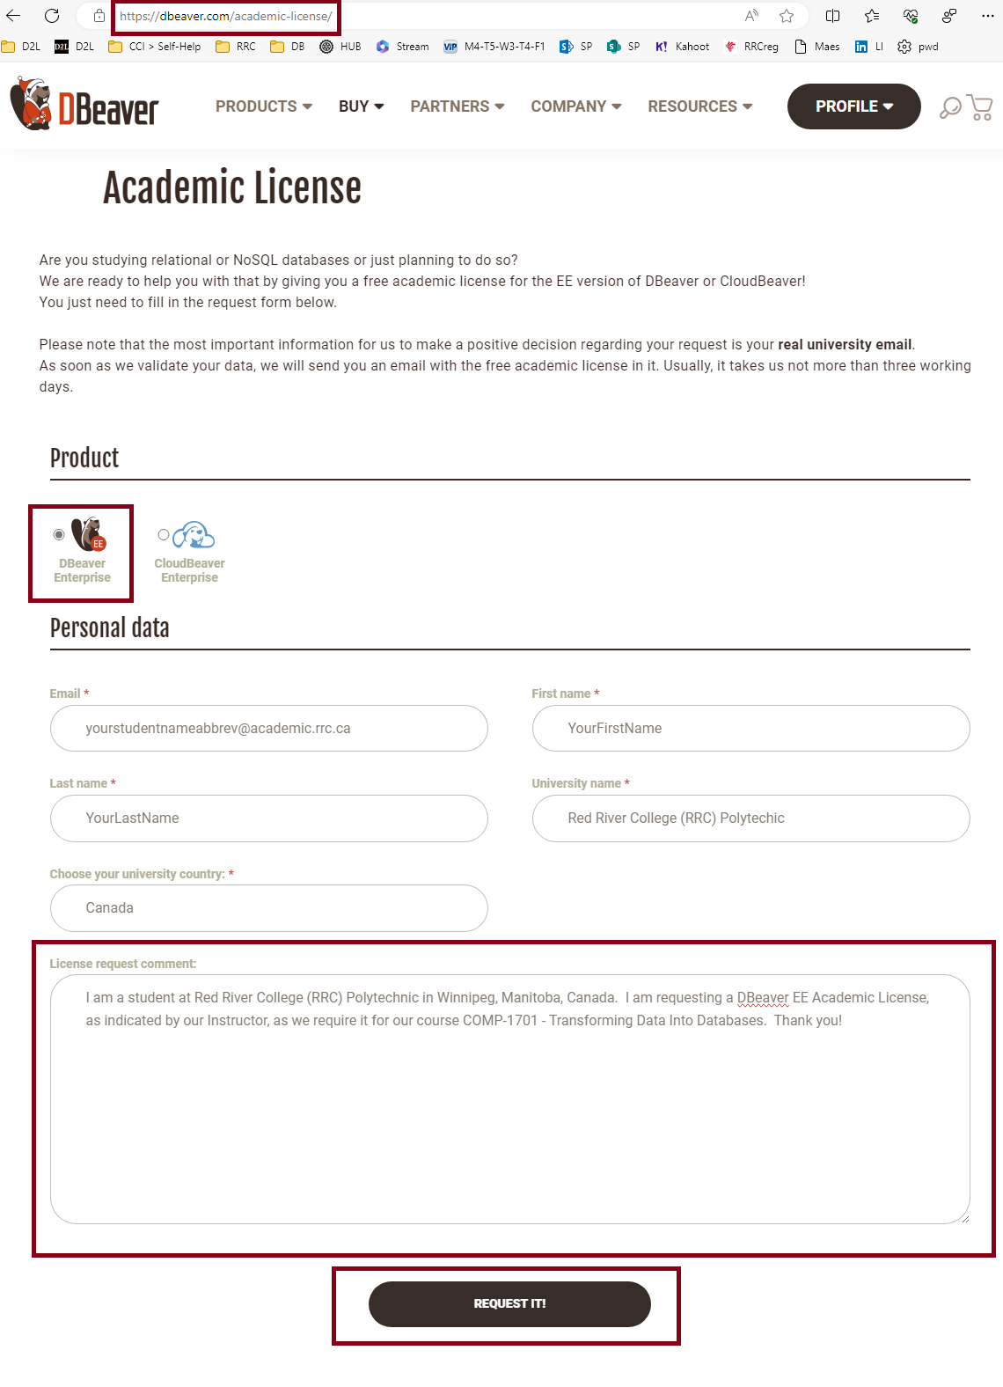

After complete, click **REQUEST IT**! and you will get the following message:

Note: Third-Party Request Etiquette  
  
Always be grateful/respectful to those Third-Parties you contact, you never know what it might lead to. Good relationships can lead to super deals later on, not always, but has happened!!

Notably, you will receive a message about your Academic License Request

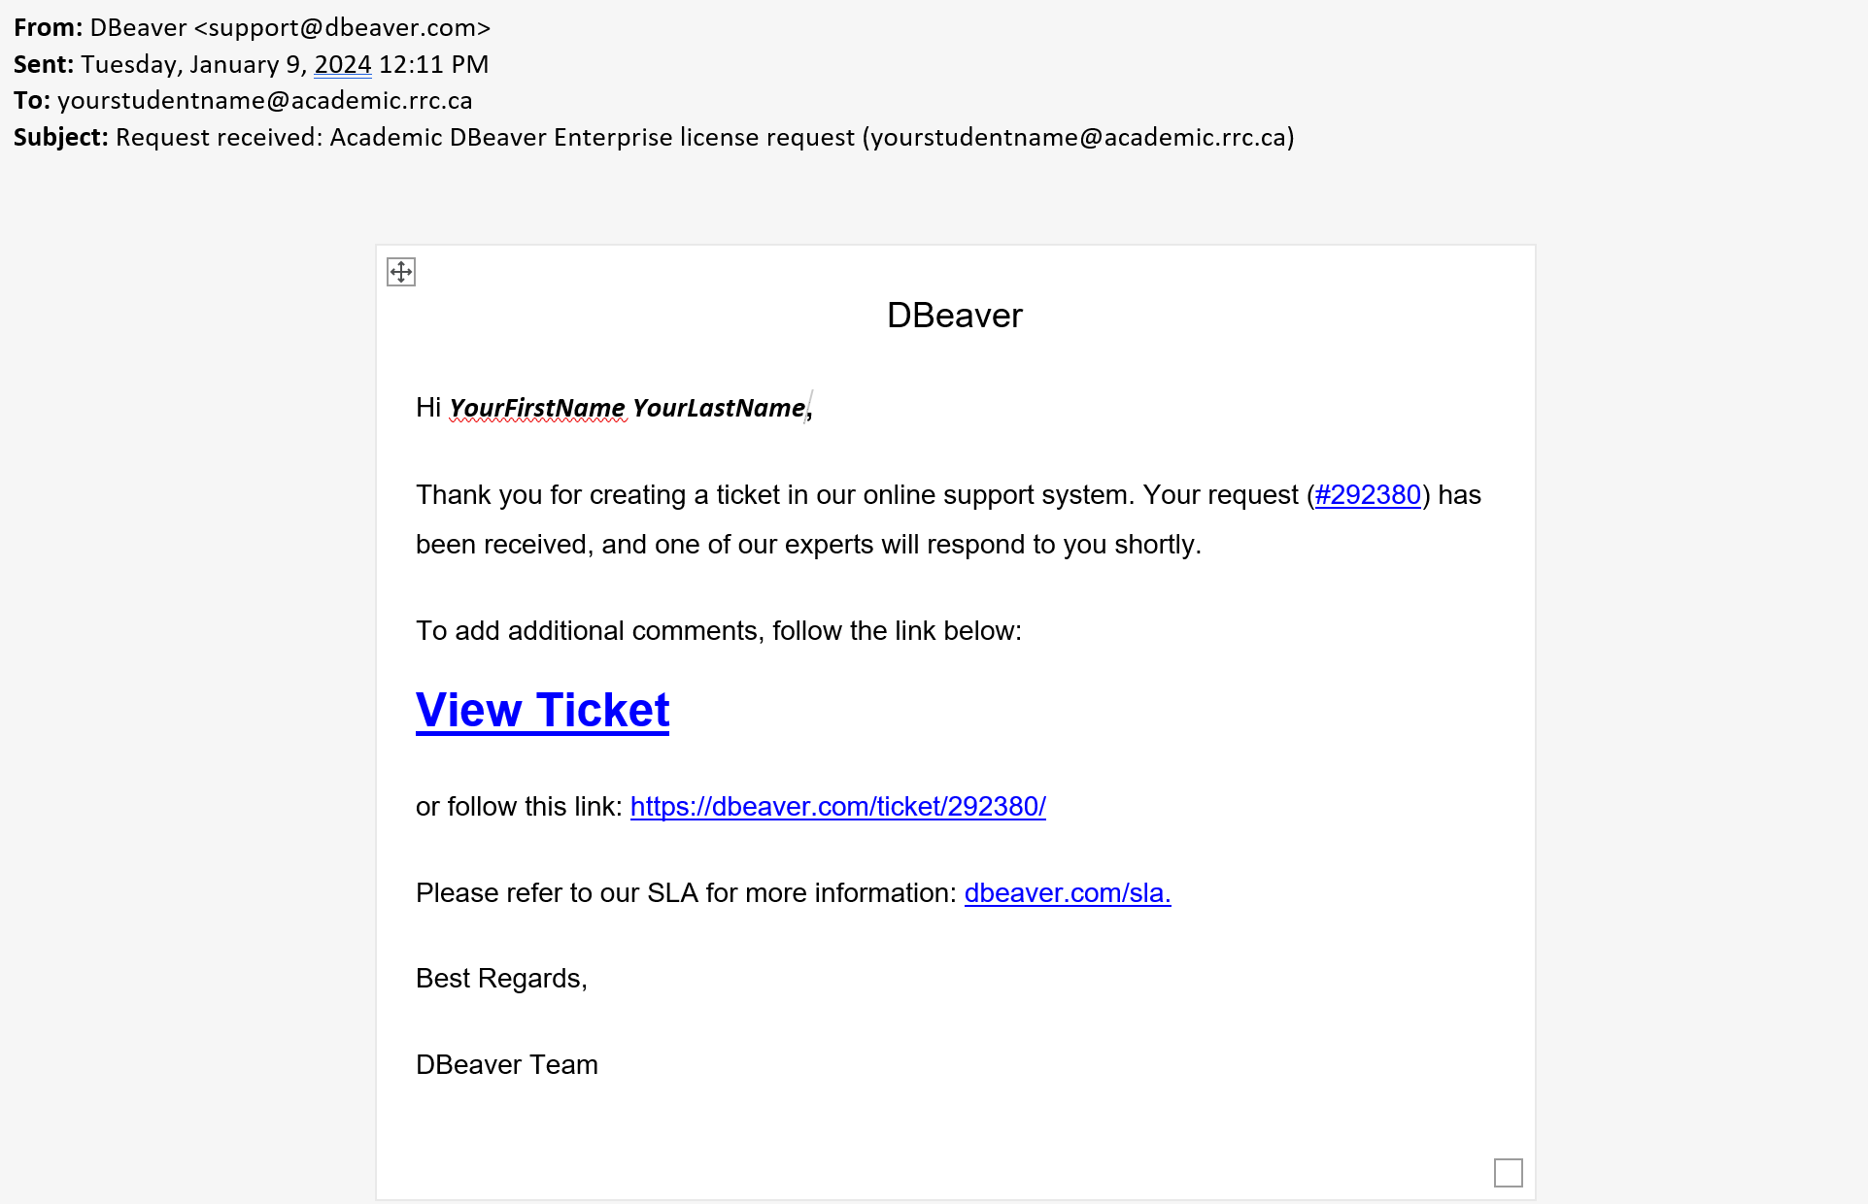

Under your Profile, you will see Account and Tickets options.

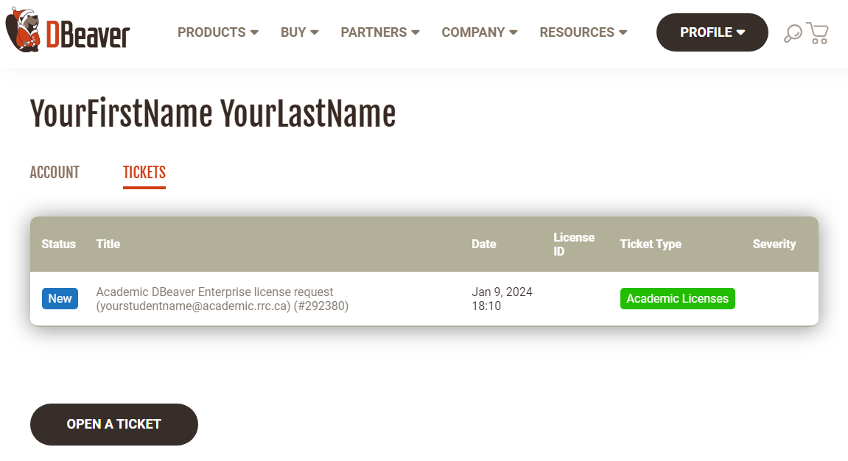

Once your request has been approved, you will see the following view, including Licenses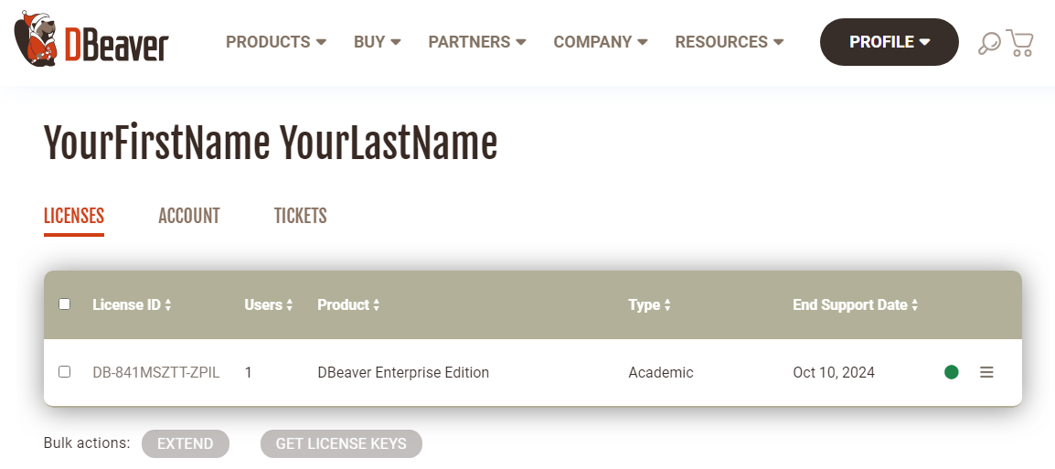

Download Process

Leave this screen open, and go into the Products menu, and right-click DBeaver Enterprise (choosing Open Link in New Tab):

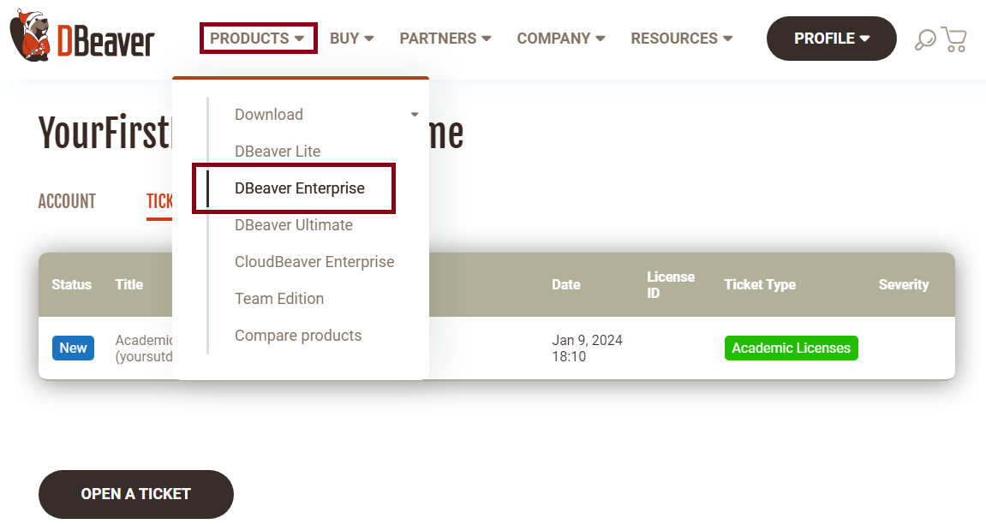

Click the DOWNLOAD button

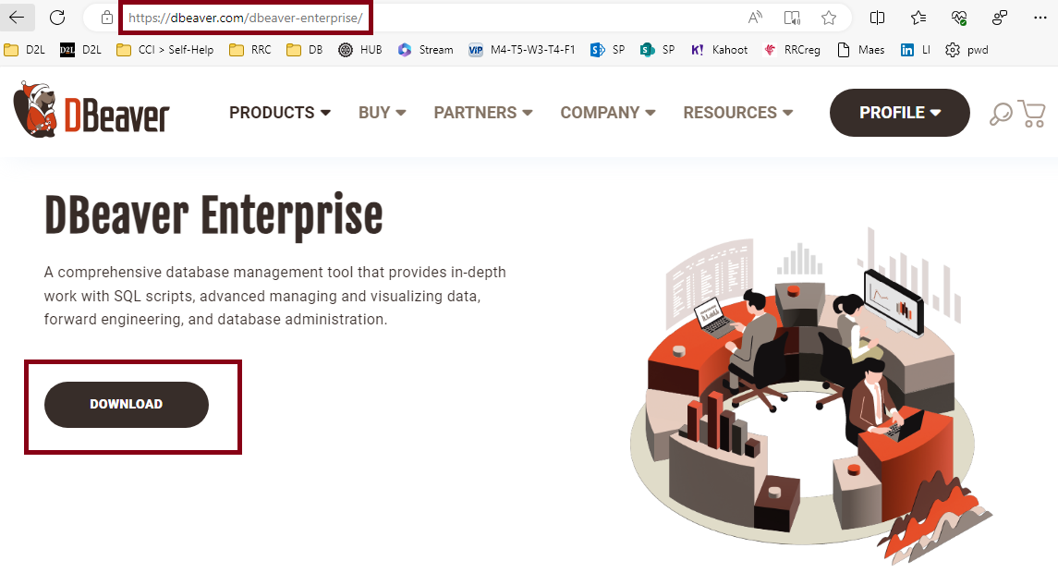

It should default to your Operating System, however if it doesn’t choose the appropriate download for DBeaver EE (not the ZIP), should be for Windows DOWNLOAD | .EXE button or for Mac OSX either INTEL or APPLE SILICON.

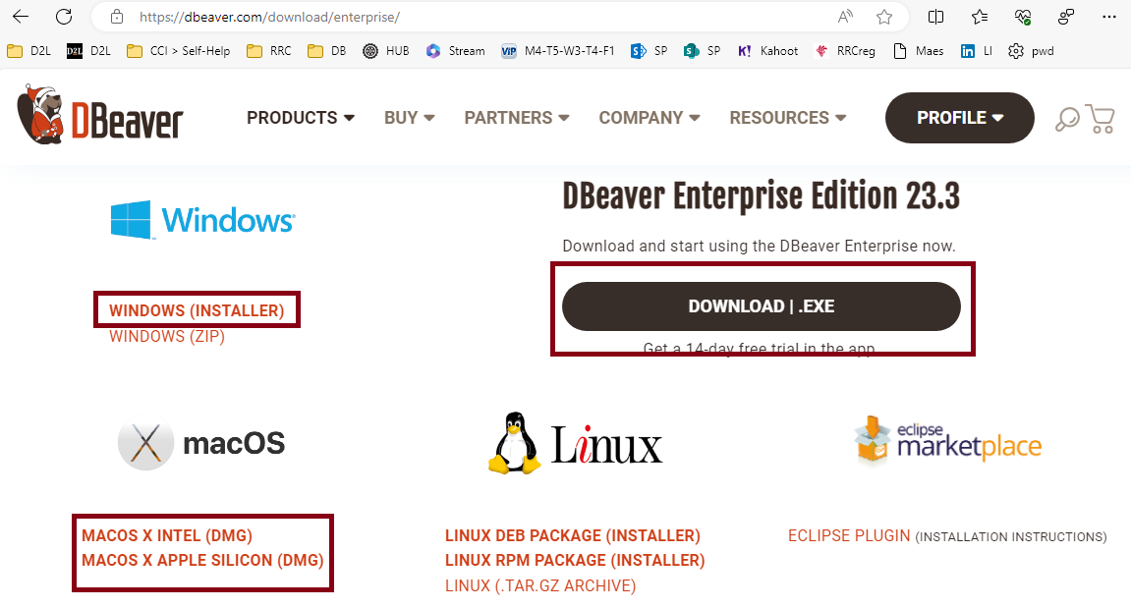

Downloading will commence, so you should head over to you File Explorer/Finder window’s Downloads folder:

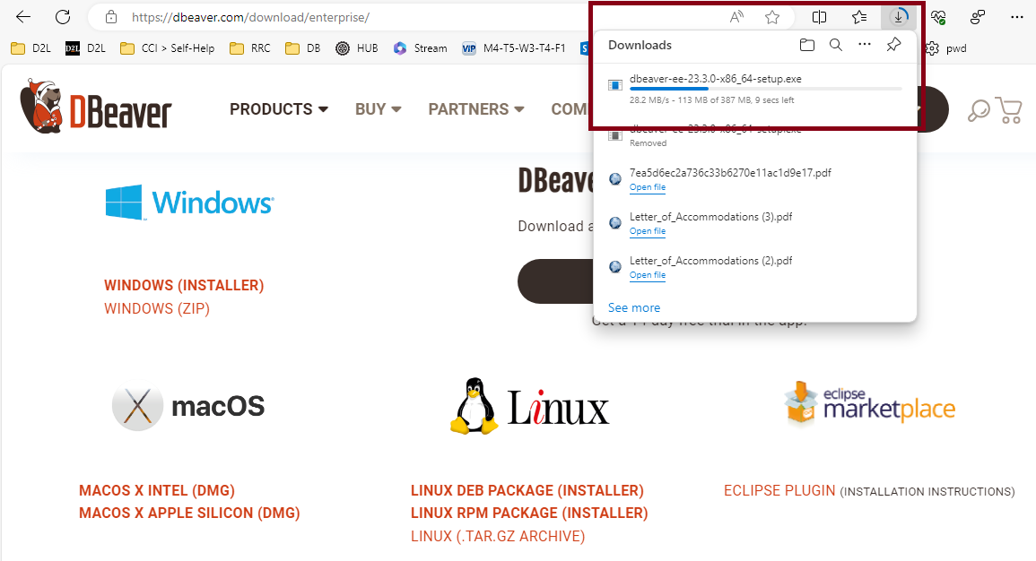

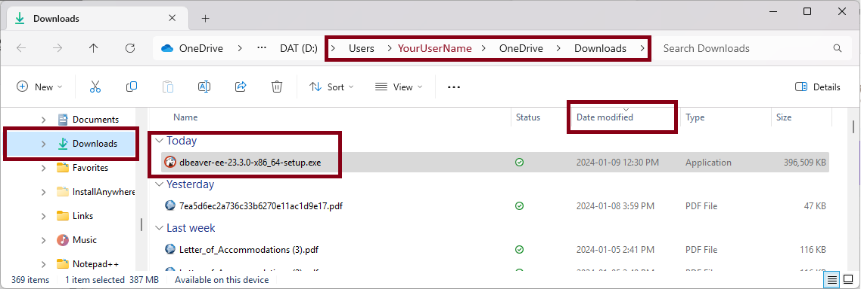

Double click the downloaded dbeaver-ee-* install file, and proceed through the installation.

Install Process

Choose **English**

NOTE: not applicable here, though if ever it indicates a Country, like English (US), choose that, as most software is US born, compatibility reasons)

Click **Next** on Welcome screen and **I Accept** on License Agreement screen

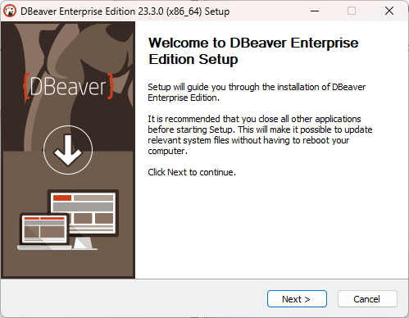

Chose **For me** (lists YourUserName) and **Top 3** **Components** on Components screen (*don’t select Associate .SQL files, sometimes opens multiple instances of DBeaver*)  
  
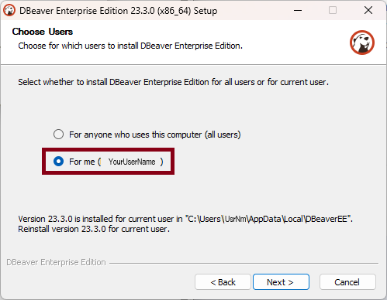 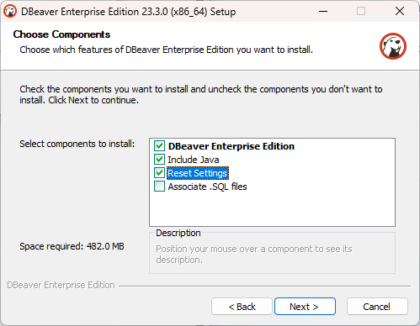

**Choose Install Location** and **Start Menu Folder** screens, just click **Next** on each (noting it is being installed in a Hidden Folder, within your User Profile’s AppData folder, so good to unhide those via your File Explorer, with the Show File Extensions shown as well):

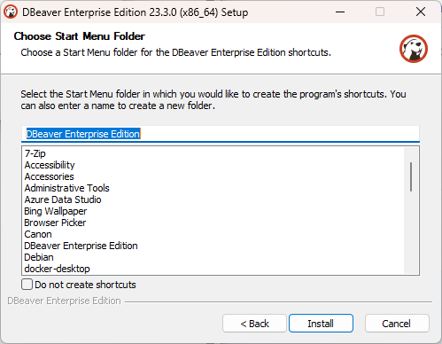

Click **INSTALL** and on the last screen, **DO NOT** Create Desktop Shortcut, just click **FINISH**:

**

Open DBeaverEE & Apply Academic License

On the previous tab, click the License ID hyperlink (in red below):

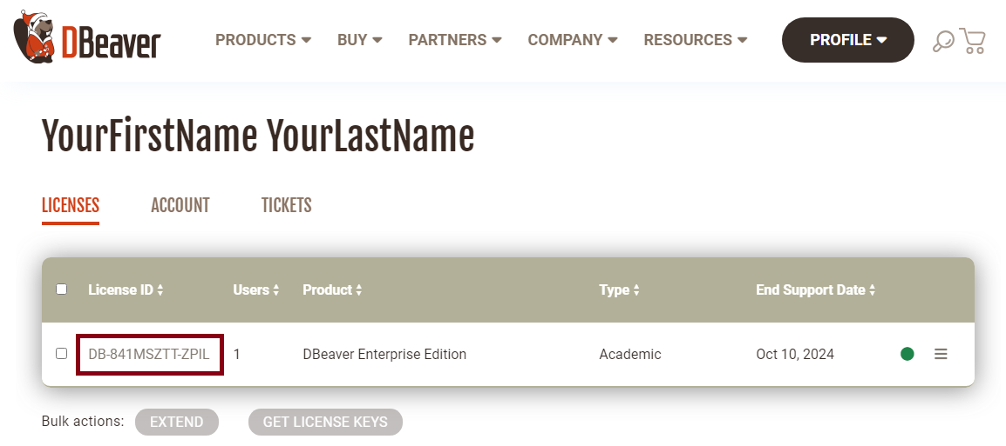

On the resulting page, click on the **COPY TO CLIPBOARD** option

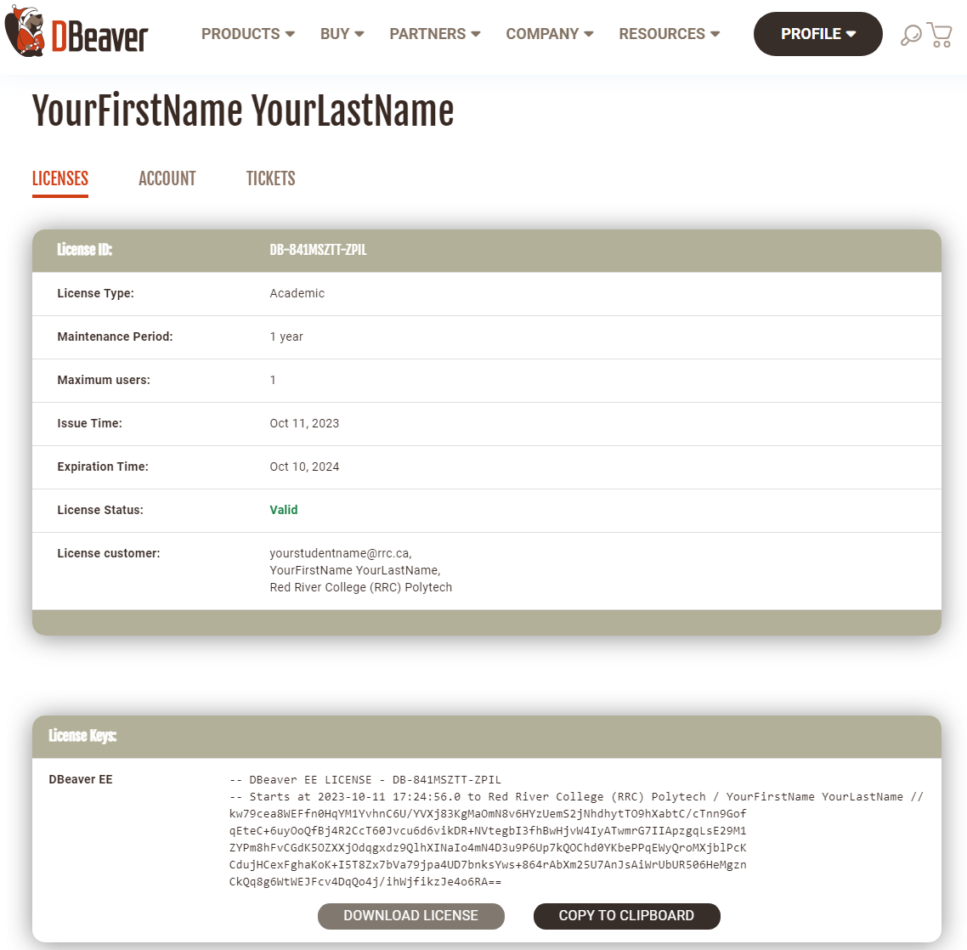

Open **DBeaver** from your **Windows Start Menu**, once you see the icon show up on your Taskbar, you should ***right-click*** on it and **Pin to Taskbar**, for quick access)

When opened DBeaver is opened, you may see a **Data share** window, as DBeaver EE is giving us this for free, I think it is find to **Send anonymous statistics** at the very least.

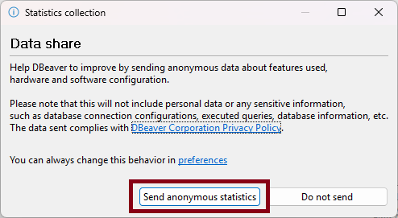

Depending on whether you’ve opened your DBeaver EE prior to getting your license (and choose to enable the Trial Version), you can either look for an option to **Import (License)** prompt on first open, or goto your **Help** > **DBeaver License Info (bottom) > License Manager > Import**, and do the Import there.

From the previous **COPY TO CLIPBOARD** should have that license in your Window Clipboard, so you just need to click **Paste** in the **Import License** window:

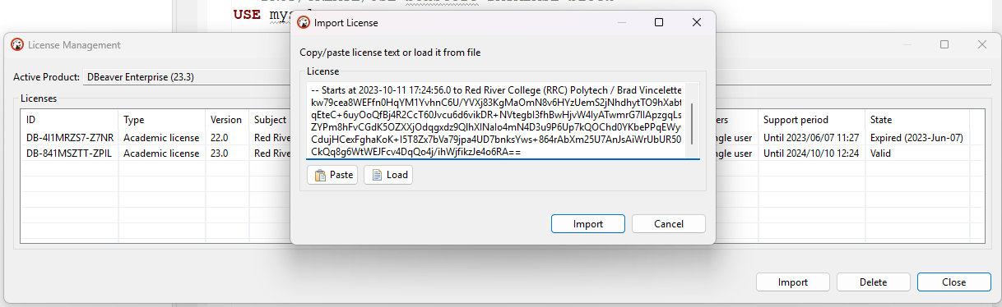

Click **Import** button, then it should say **Valid** in your **License Management** window.

Connecting DBeaver to MariaDB/MySQL

First you need to choose the Database Engine you installed, ***Windows*** was **MariaDB**, ***Mac OSX*** was **MySQL**, both icons are depicted noted below.

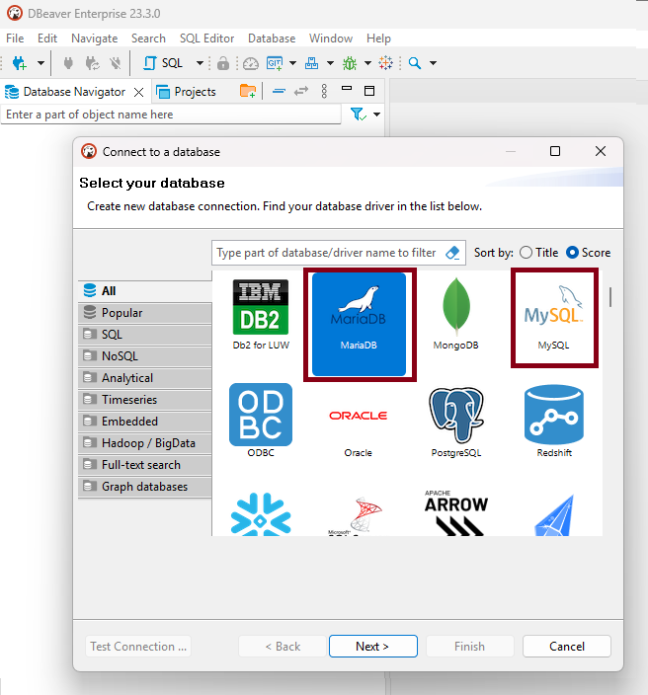

First we need to connect to the database server, which should have the Server Host: localhost (127.0.0.1)  
Port: 3306  
Username: root  
Password: (your root password from the MariaDB/MySQL install)  
  
Then click on **Connection details** **(name, type, …)** button:

Your Connection name should include localhost, then a hyphen – and then you **MariaDB_##.#** or **MySQL_#.#** **Service** name that should include the ***version number***, as shown below. **Navigator view** should be set to **Advanced**

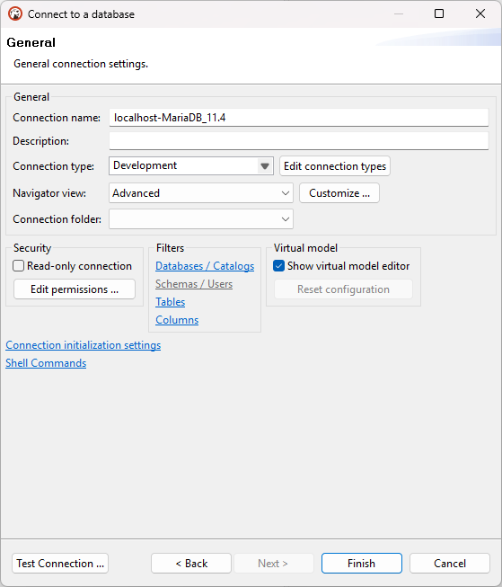

Now click on Test Connection and you should receive the Connected prompt (below).

NOTE: a prompt will appear asking you to install the JDBC drivers for these connections to work, please click to download and install them

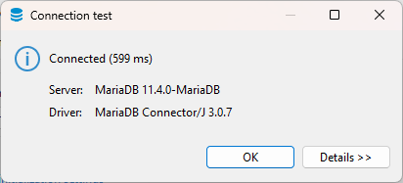

With all the connection items completed, you should be in your GUI window now.

PLEASE OPEN YOUR BOXSTORE SQL FILE NOW! (File > Open)



On the menu, you will see 2 menubar items that say **N/A** and **N/A**, this is your **server host** and **database name**, which need to be selected, which should be the **localhost-MariaDB_##.#** or **localhost-MySQL_#.#** for your database server/engine connection. And the database should be your **fl_studentid_boxstore** database name, as ran in the previous lecture.

If you do not see the boxstore database in the listing on the left index (when expanding the **localhost-\*** and **Databases** left index options, goto File and Open File… and find your fl_studentid_boxstore.sql file to open.

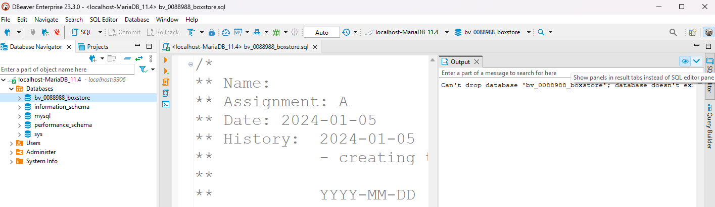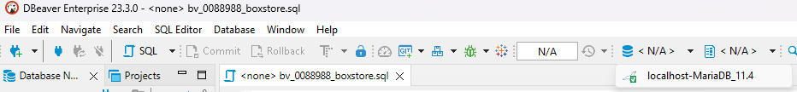

Everyone, should still **open** their **boxstore** SQL file, as this is where you will be working on it from, **only here**.

Highlight your **DROP/CREATE/USE** block code (depicted below), and click on the **3rd Icon** in the ***vertical toolbar*** (only use that **3rd icon**, and ensure you only select the code you want to run), remember always select your code from the back to the start of the block you want to run:

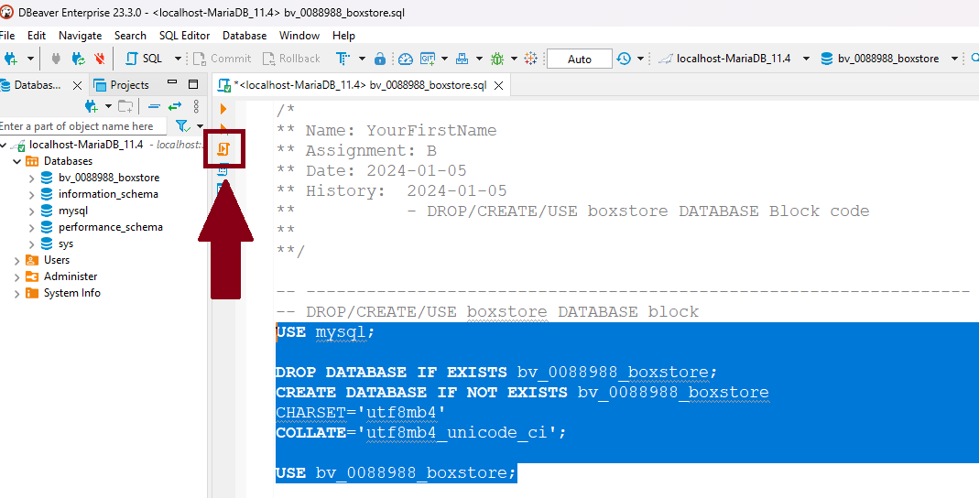

Thereafter, in the ***left index***, ***right-click*** on the **Databases** item, and select **Refresh** from the ***popup menu***, you should see your database listed now, and you can also select it in the top toolbar on the right side (where it may be still showing N/A)

Configuring DBeaver

Right-click on your localhost-(MariaDB/MySQL) option in the left index and choose Edit Connection from the popup:

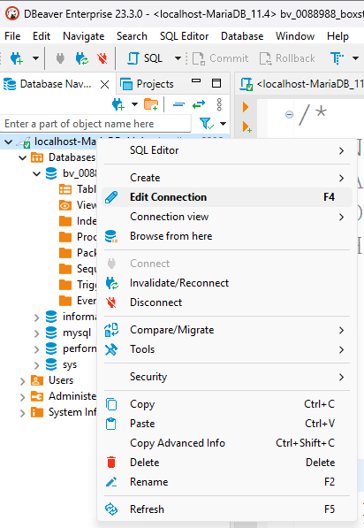

Under **General**, you can adjust your **Connection name:** (if entered incorrectly) and choose the **Navigator view:** to **Advanced**.

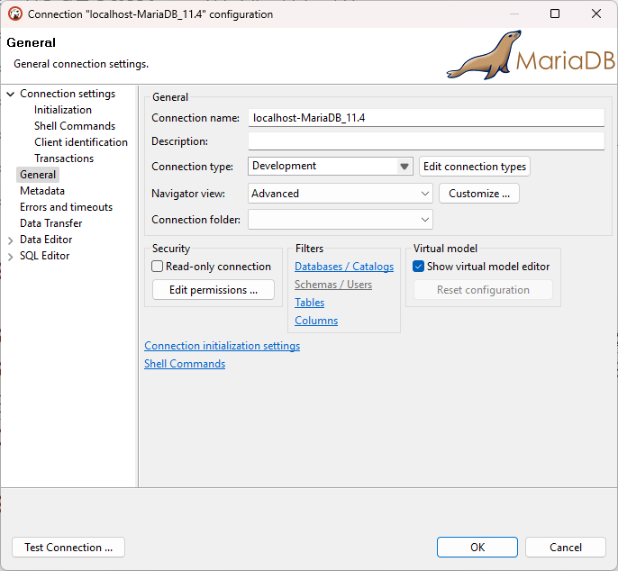

Expand SQL Editor and choose Code Completion (in the left index) and click on **Global Settings** in the right corner (below the Respective Database logo)

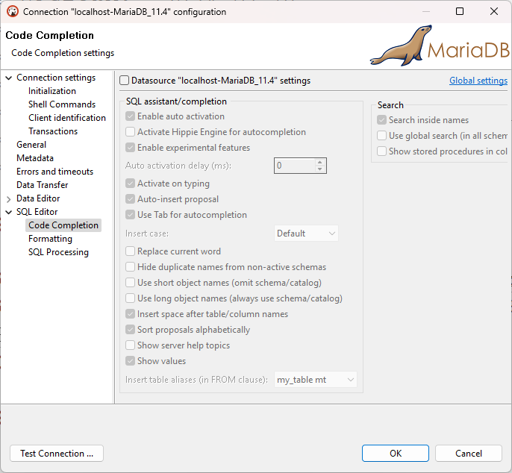

If done correctly, it should change to ***Datasource Settings*** in place of ***Global Settings***. **Please check and uncheck the setting options to match your settings**:

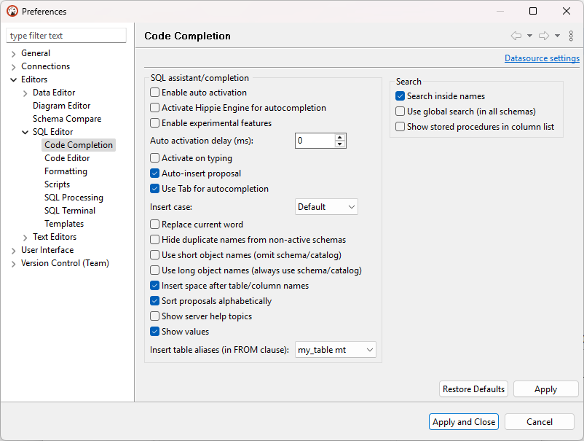

Then goto **Code Editor**, ensure the options below match your settings:

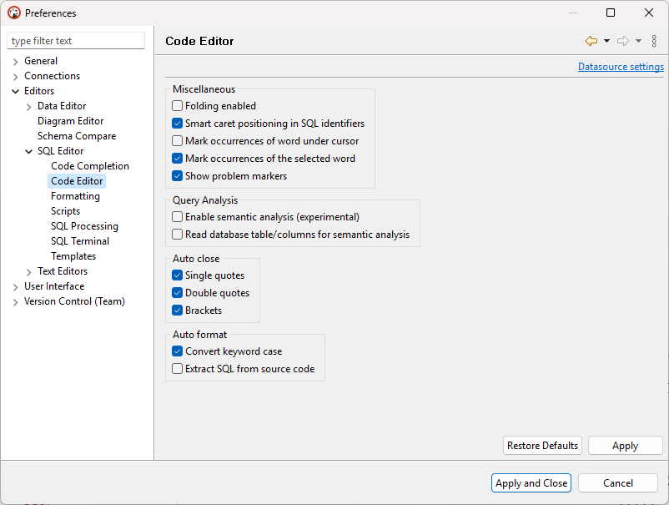

Then goto **Formatting**:

* uncheck Format active query only
* Keyword case: Upper (must be selected)
* Indent size: 4
* check Insert Spaces for tabs
* check Insert line feed before commas

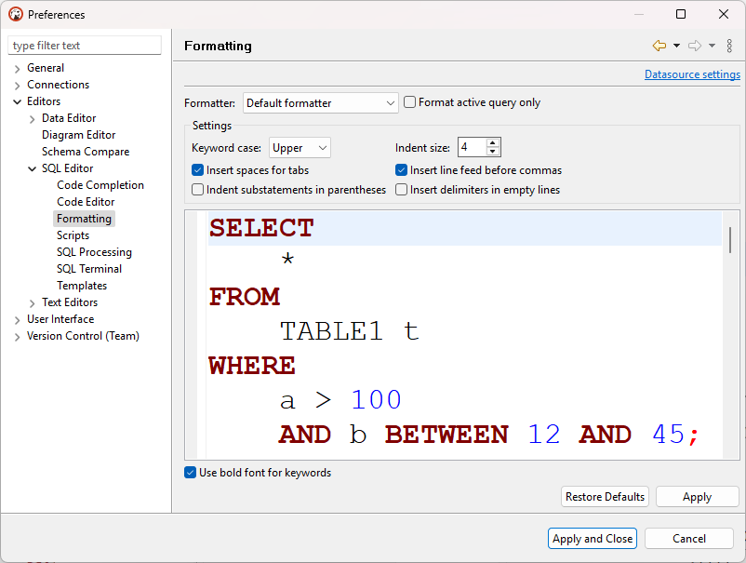

Then click Apply and Close and it will reconnect your connection.

And you are done.

Executing SQL Commands in DBeaver

Please remember, only highlight **(with your newly purchased mouse, hint hint)** the SQL Code you want to run, and remember to only click the 3rd Icon from the top in the Vertical Tool bar:  
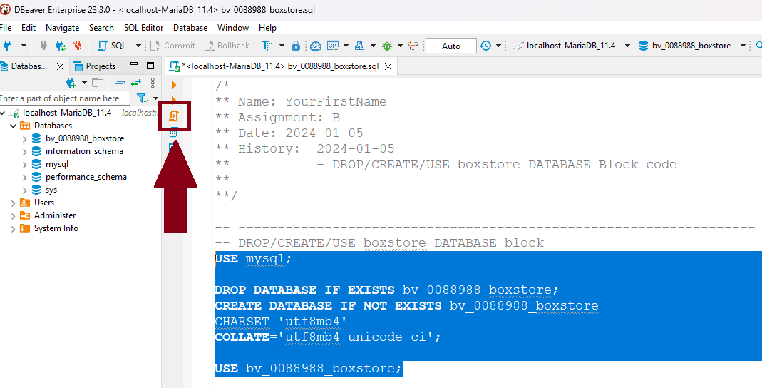

Also if an **Output** window appears, click the ***blue down arrow button*** to drop it to the bottom area, where your **Statistics**, **Results**, and now **Output** panes will now appear.

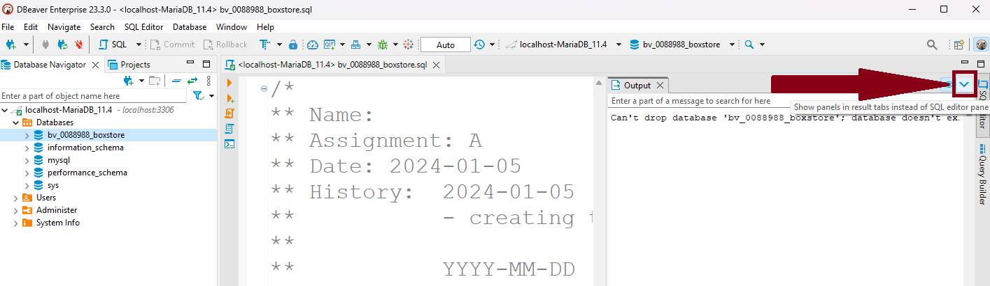

And this concludes the DBeaver install configs. Good Job!

## 